“Starbucks Stock Analysis Report”

*Empowering Financial Decisions with SQL: A Deep Dive into Stock Performance and Corporate Actions*



# 1. Overview

This project leverages SQL to explore and analyze Starbucks’ historical stock performance and corporate actions. The goal is to extract insights that help investors and analysts understand trading behavior, dividend patterns, and market volatility. The insights derived from this analysis can support better financial forecasting, risk evaluation, and investment planning.

# (Power Query + SQL Integrated project)

# _MOHAMMED AMEEN PA_

## 2. Problem Statement

Modern financial analysts and investors have access to vast volumes of trading data but often struggle to extract actionable insights. Without structured data models and SQL-driven analytics, understanding long-term patterns such as dividend growth, market volatility, and trading behavior becomes difficult.

**Key Challenges:**

* Unstructured and denormalized raw datasets.
* Difficulty identifying high-activity periods or performance trends.
* Limited visibility into dividend and split events over time.

**Objective:**

* Normalize and structure the data into separate analytical tables.
* Use SQL queries to derive insights on price trends, trading volumes, and dividend patterns.
* Present key financial insights for better investment decisions.

# 3. Data Description

The dataset consists of Starbucks’ daily stock trading records and corporate financial actions (dividends and stock splits).

|  |  |  |
| --- | --- | --- |
| **Table** | **Columns** | **Description** |
| stock_history | trade_date, open, high, low, close, volume | Records daily price and trading data |
| stock_actions | action_date, dividends, stock_splits | Records corporate financial events |

**ERD DIAGRAM:**

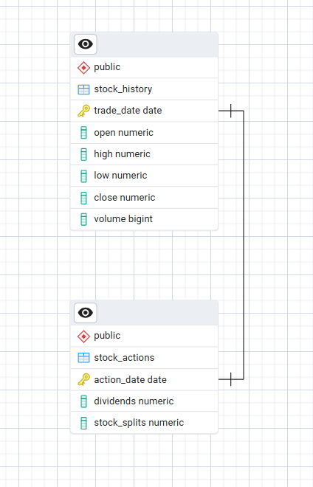

**INSIGHT:**

This diagram shows that two tables relationship type follows one to one relationship.

The two tables are stock_history and stock_action these 2 tables are connected with the primary keys trade date and action date .

# 4. Key Analytical Queries and Insights

## 1. Highest Stock Price

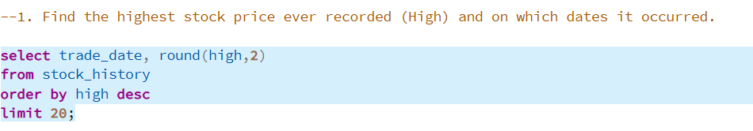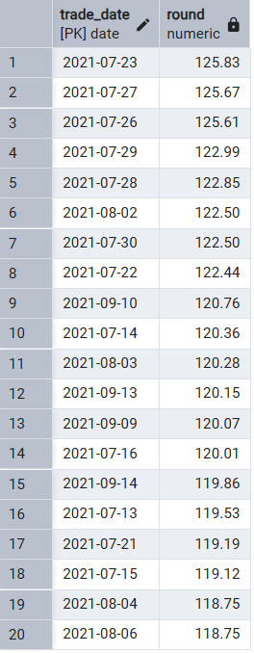

### **Insight:**

*Shows the days when Starbucks stock reached its highest price ever.  
This helps investors identify* ***historical performance peaks*** *and use them as* ***reference points*** *for future growth comparisons.*

***Recommendation:***

*Use this as a* ***benchmark*** *for future performance goals.  
If current prices are much lower, Starbucks could* ***communicate long-term growth strategies*** *to rebuild investor confidence*

## 2. Average Closing Price per Year

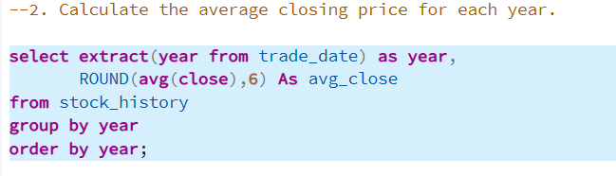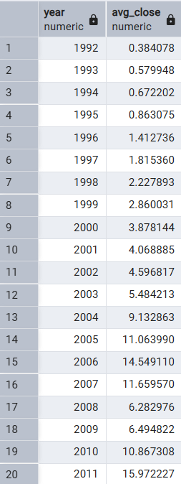

### **Insight:**

*Displays how the stock’s closing prices have changed each year.  
This indicates* ***overall yearly performance trends*** *and helps understand* ***long-term stability or growth****.*

***Recommendation:***

*Analyze what caused those large swings ,  
Starbucks should* ***improve communication*** *and* ***timing of announcements*** *to reduce market uncertainty and stabilize investor reactions.*

## 3. Highest monthly Volatility

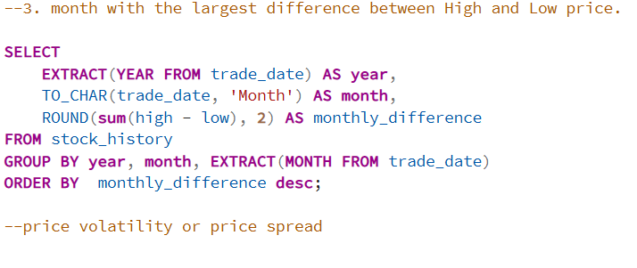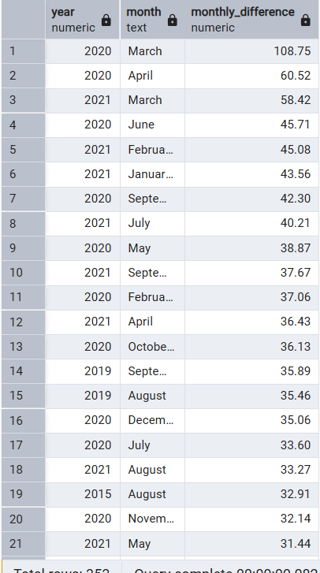

### **Insight:**

Highlights the month with the **largest price swing** between high and low values.  
This is useful for identifying **high-risk or high-opportunity trading months**.

**Recommendation:**

Starbucks should **strategically align major announcements** (like product launches or earnings) with these high-interest months to **maximize visibility** and **investor engagement**.

## 4. Average Monthly Trading Volume

## 

### **Insight:**

## Shows how many shares were traded on average each month. It reflects investor interest, liquidity, and how active the stock market was during different months.

**Recommendation:**

During low-volume months, Starbucks can **release investor updates or promotional news** to spark trading interest.  
During high-volume months, **ensure positive engagement** to strengthen investor trust.

## 5. Top Trading Volume months

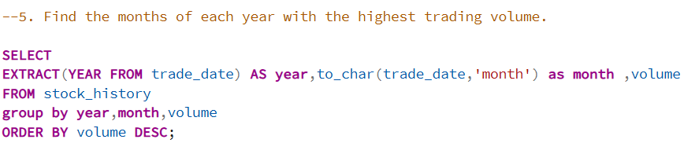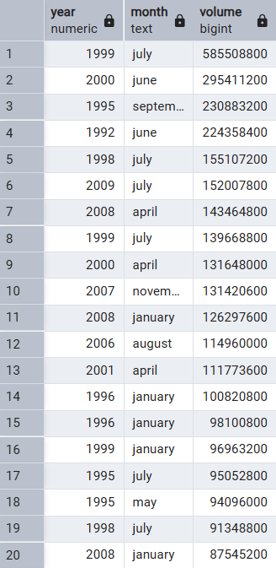

**Insight:**

**Identifies months with the highest market activity.  
Such spikes often occur during quarterly results, corporate announcements, or economic events that affect investor behavior.**

**Recommendation:**

Starbucks should **strategically align major announcements** (like product launches or earnings) with these high-interest months to **maximize visibility** and **investor engagement**.

## 6. Dividend Payment History

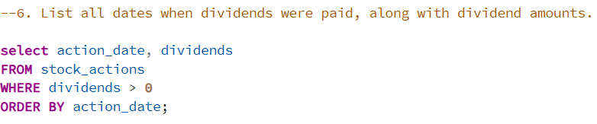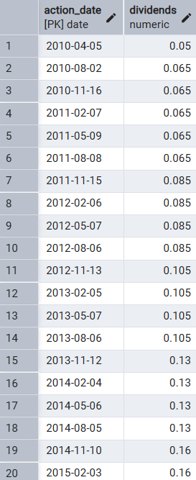

### **Insight:**

*Shows Starbucks’ payout trends and helps assess shareholder return consistency.*

**Recommendation:**

Continue providing **regular, stable dividends** to reinforce investor confidence.  
If dividends are inconsistent, Starbucks should **stabilize its payout policy** to attract long-term, income-focused investors.

## 7. Stock Split Count

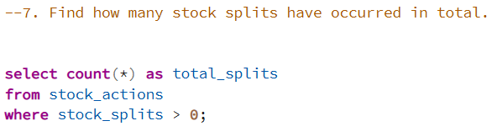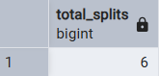

### **Insight:**

*Displays how many times Starbucks has* ***split its stock****.  
Frequent splits usually mean the stock price has risen significantly — a* ***sign of company growth and market confidence****.*

***Recommendation:***

*If the share price becomes very high again, consider another* ***stock split*** *to make shares* ***more affordable*** *and increase* ***market liquidity****.  
Avoid unnecessary splits unless backed by strong financial growth.*

## 8. Yearly Dividend vs. Average Closing Price

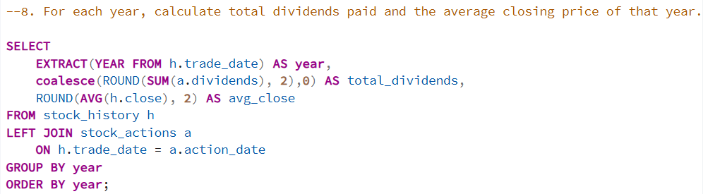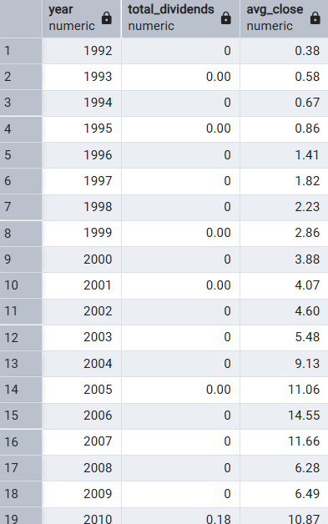

### **Insight:**

Compares **dividend payouts** to **average yearly stock prices**.  
It helps measure whether **higher dividends** are linked with **stock price growth**, showing **value creation** for investors.

**Recommendation:**

Maintain a **balance between dividend payouts and stock growth**.  
If prices rise but dividends remain flat, Starbucks can **slightly increase dividends** to reward investors and signal confidence in earnings.

## 9. Rank Top Trading Days by Volume (can be changeable as per the year)

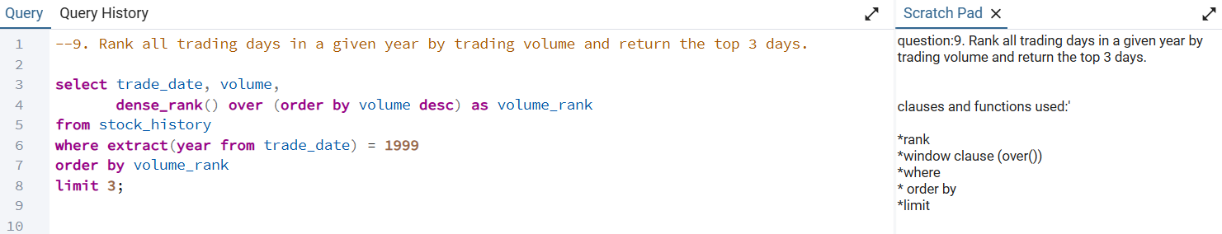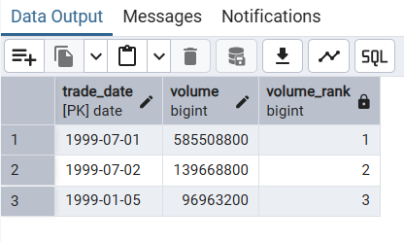

### **Insight:**

*Identifies key high-activity days — valuable for short-term traders and market analysts.*

Market Maturity:

As a company grows, the stock often stabilizes — traders lose interest, and only long-term investors remain.

Share Buybacks or Splits:

If the company performed a stock split or buyback, the number of shares available for trading can change, reducing volume.

**Recommendation:**

Review these dates to identify **key triggers** (earnings, news, policy changes).  
Use such data to **forecast future trading spikes** and plan announcements to **leverage investor attention**.

## 10. price changes on dividend days

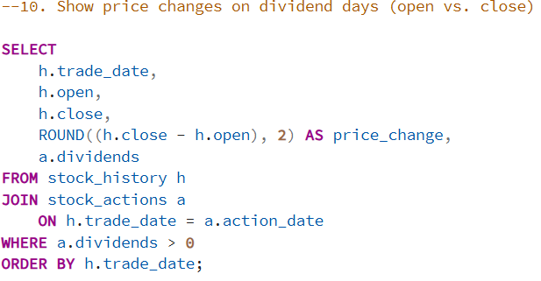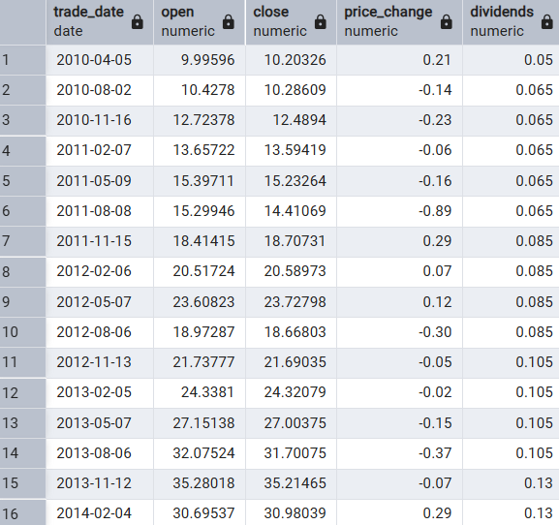

### **Insight:**

*Smooths price fluctuations, and are able to understand that the price difference on dividend dates.*

**Recommendation:**

If prices drop after dividend announcements, **adjust communication timing** to manage investor expectations.  
If prices rise, highlight this in investor reports to show **positive sentiment** around Starbucks’ dividend policy.

# 5. Insights and Conclusions

The SQL-based exploration of Starbucks’ stock data provides the following insights: Consistent growth patterns with stable long-term averages. - Noticeable volume surges align with corporate announcements and dividend dates. - Regular dividend payouts reflect steady company performance. - Volatility analysis identifies critical risk periods for investors. - Data normalization ensures reliable and scalable financial reporting. In conclusion, this analysis demonstrates how structured SQL queries can transform raw stock data into strategic business intelligence. The findings can guide investors, analysts, and management teams toward better forecasting, performance tracking, and investment decisions.